ASSESSMENT 3
- SRUTHY SUJI
- 23AD140
- AI-DS C

Problem Statement: Real-Time Monitoring and Optimization of FMCG Warehouse Operations Using Kafka and Spark Streaming

Objective:
Design a real-time data processing pipeline using Apache Kafka and Apache Spark Streaming to analyze and monitor operational metrics from multiple FMCG warehouses.

Tasks:
- Write a Spark Streaming Program for Live alerts for warehouse breakdowns in last 3 months “wh_breakdown_l3m” more than 3 times. [Print Status: Alert or Normal]
- Write a Spark Streaming Program for Live alerts for transport issues “transport_issue_l1y”, and storage issue “storage_issue_reported_l3m” more than 20. [Print Status: Alert or Normal]
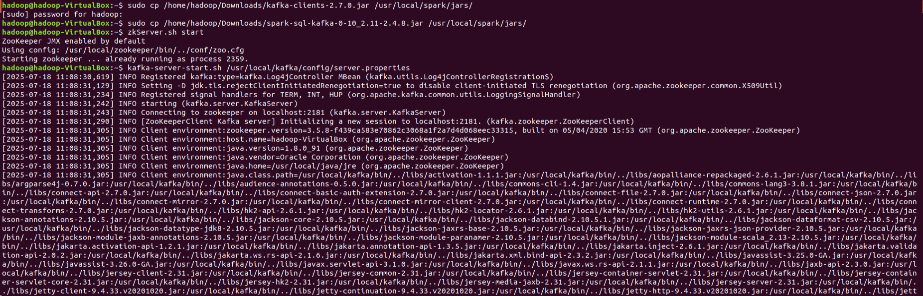

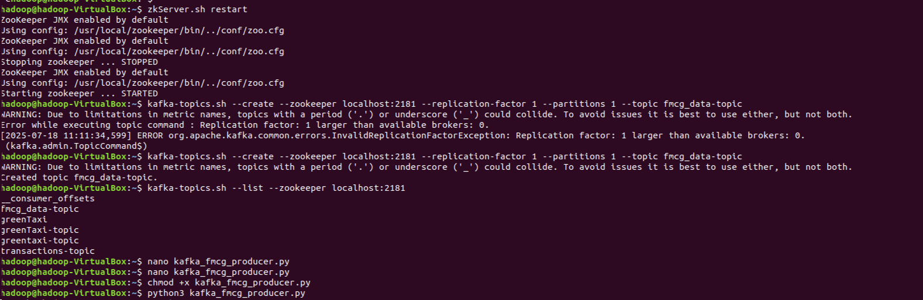

Producer codes:
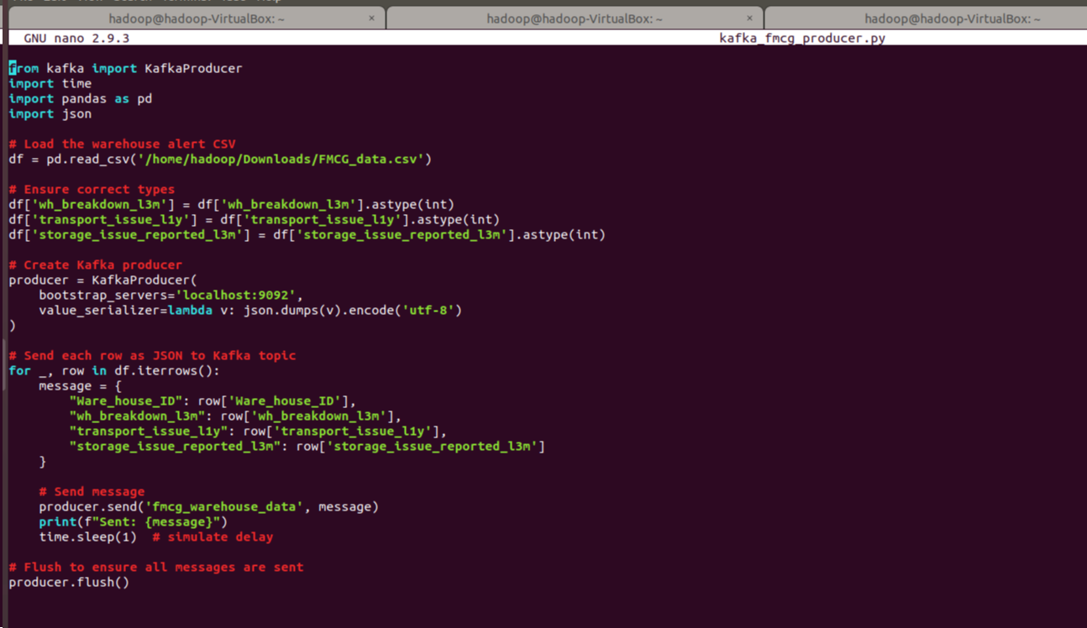

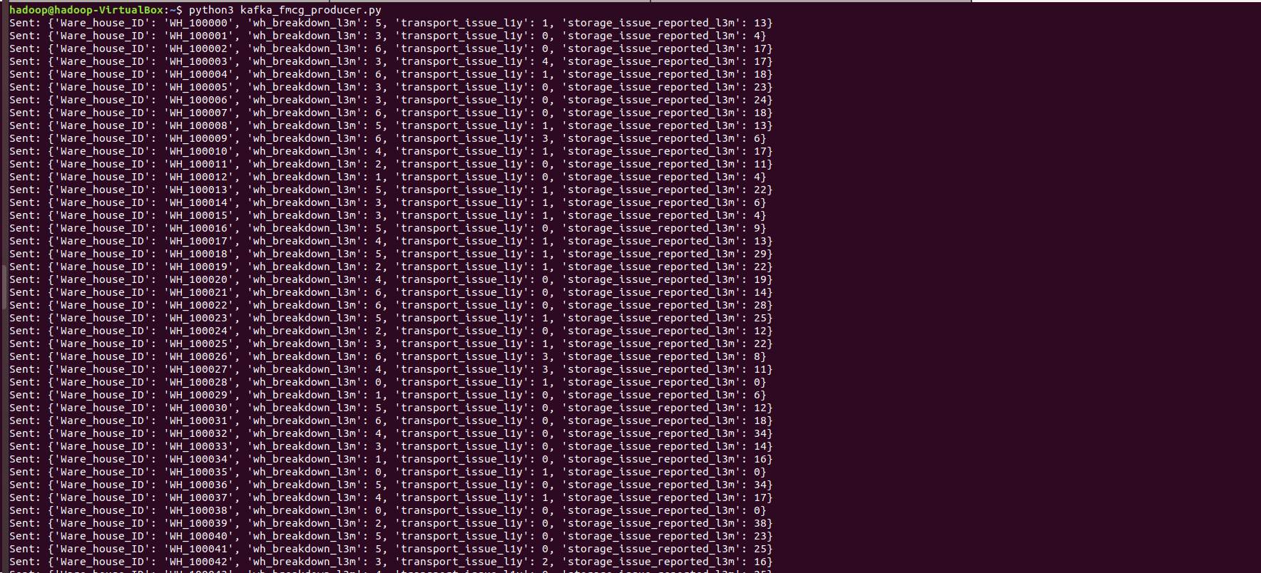

\

Consumer codes:
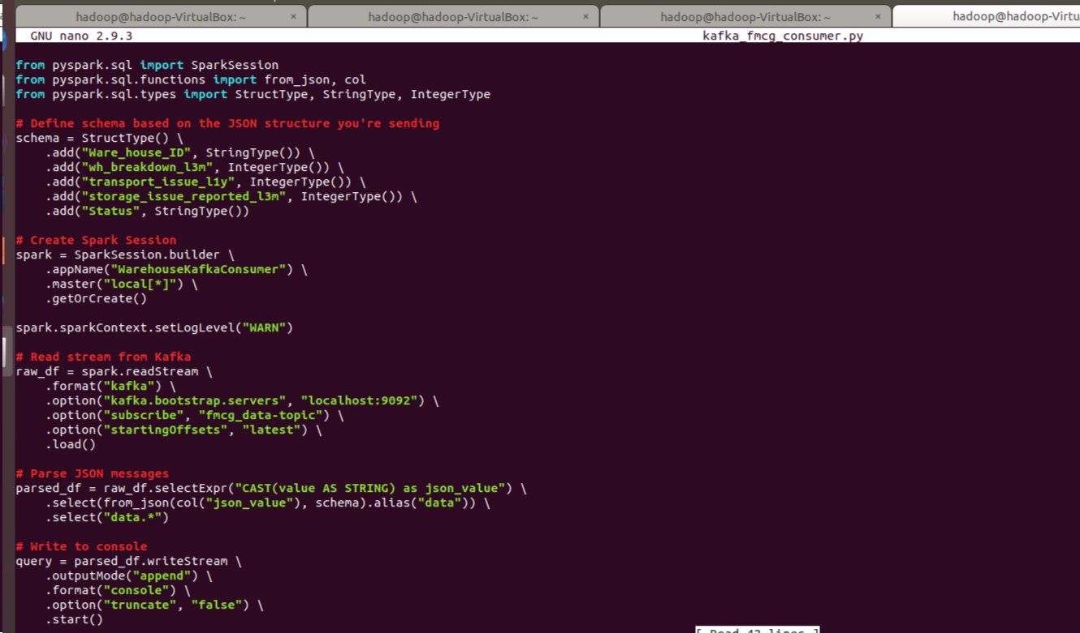

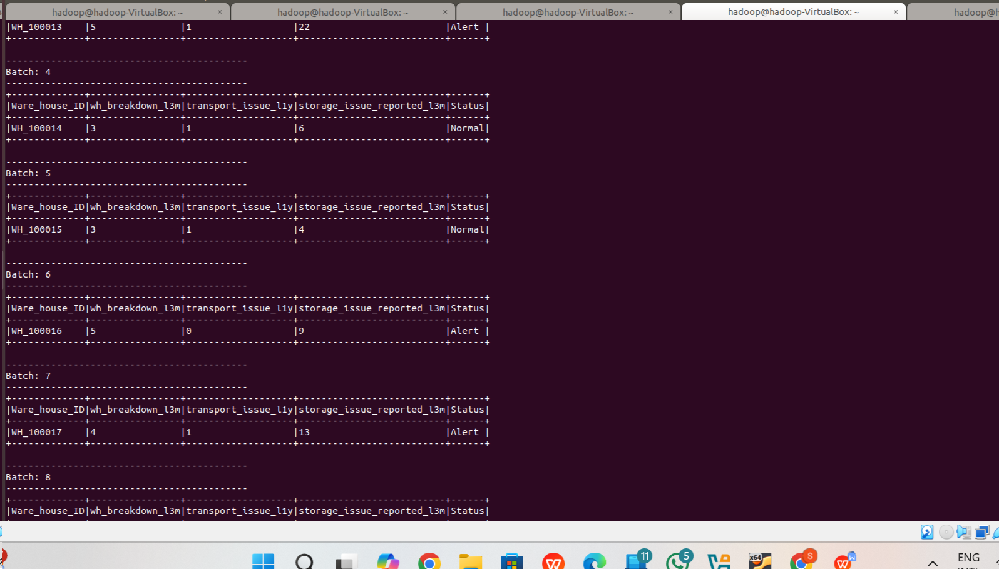

Objective: Design and implement a data analytics pipeline using Apache Spark for large-scale processing and Apache Airflow for scheduling and orchestration. The pipeline will:
• Ingest and clean warehouse data.
• Perform statistical and rule-based analysis on warehouse performance.
• Generate insights for operations, risk management, and compliance reporting.
• Automate periodic reporting.

Tasks:
- Warehouse Performance Scoring Use Fields: num_refill_req_l3m, product_wg_ton, workers_num, retail_shop_num, distributor_num • Task: Compute warehouse category based on demand and operational capacity i.e.
- Use all five fields to find Best, Worst and Medium Category warehouse. [Use Condition to Categorize WH as Best, Medium and Worst]
- Use Fields: num_refill_req_l3m, product_wg_ton, workers_num, retail_shop_num, distributor_num • Create two Spark Task files: 1) Data cleaning 2) Analysis File: Scoring formula application using DataFrame operations.
- Airflow DAG: Run this daily, store results in local FS – “/home/Hadoop/Downloads/warehouse

Program has executed

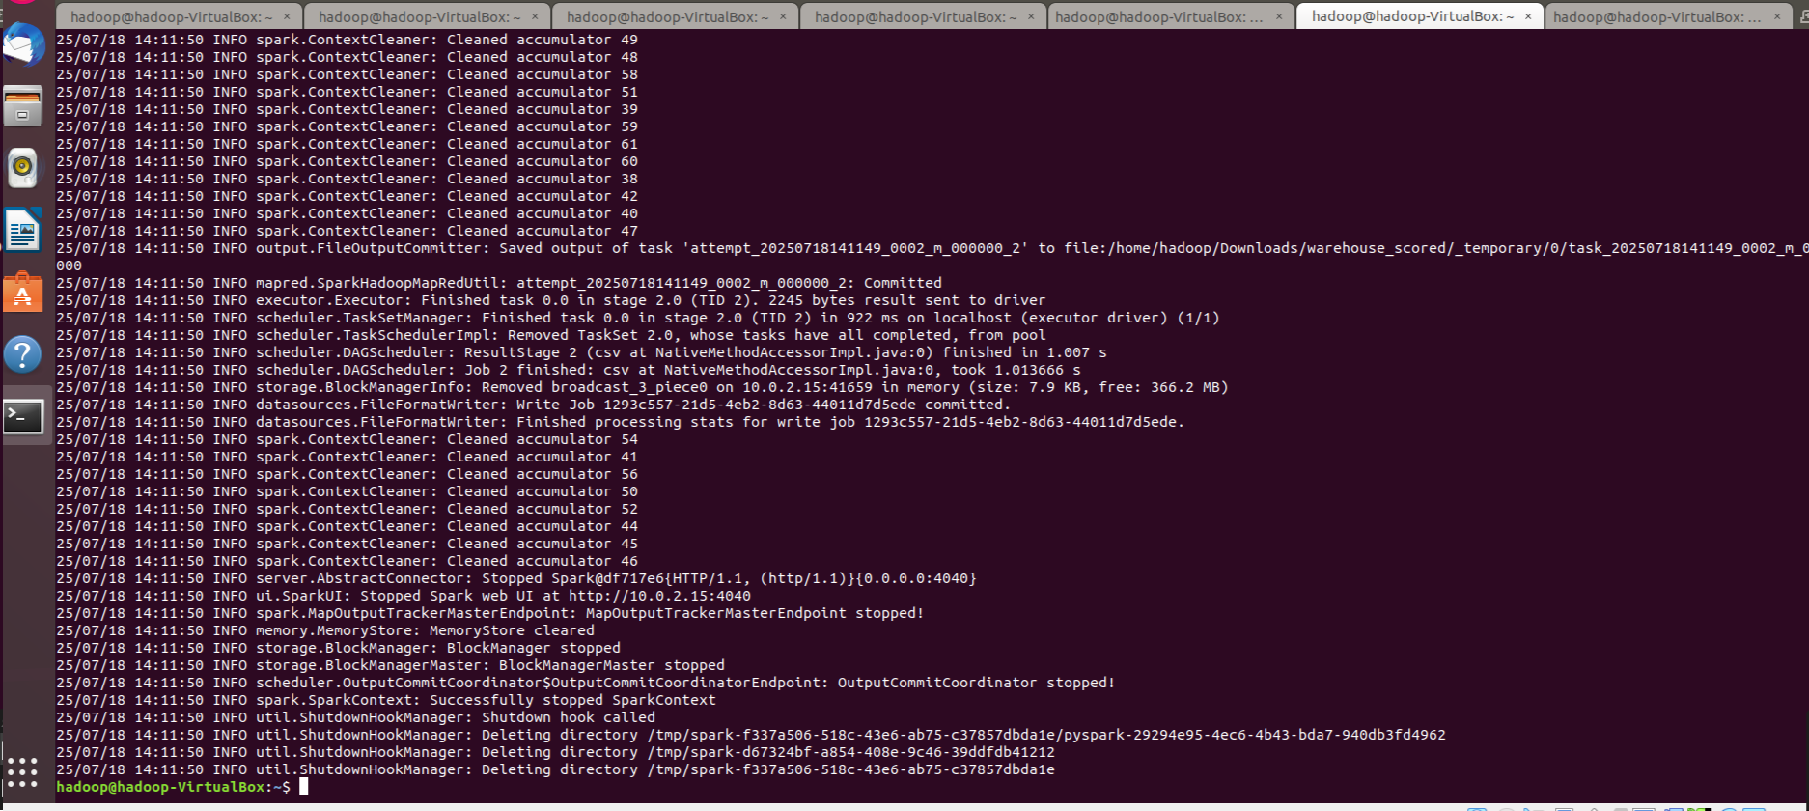

Output has been saved in /home/hadoop/Downloads/warehouse_scored
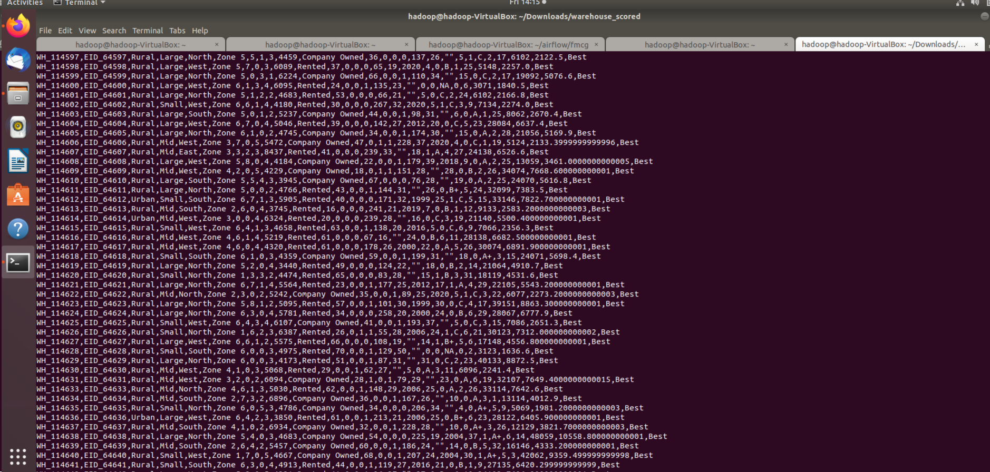

~

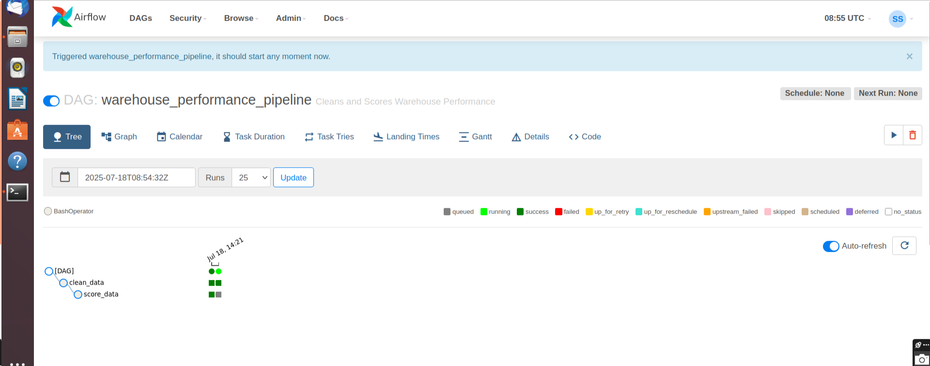
DAG :

